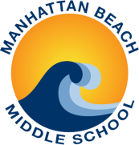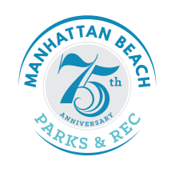**Words Into Images Intergeneration Art Show 2016**

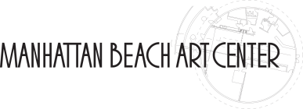**Exhibition Entry Form**

1560 Manhattan Beach Blvd, Manhattan Beach, CA 90266

310-802-5440

**Application Deadline EXTENDED to April 14, 2016**

Thank you for your interest in participating in the Words Into Images Intergenerational Art Show 2016. Opening Reception is on **May 11, 2016** from **5-7 pm**. The Exhibition dates are **May 11-14, 2016.** To have your work featured, please complete, sign, and return this form. The City of Manhattan Beach and the Exhibition Program does not provide insurance. Therefore, the artist/lender should provide his/her own insurance if necessary. The Exhibition Program is not responsible for theft, loss, or damage to any work, equipment, or personal injury beyond the City’s liability policies.

|  |  |  |  |  |  |
| --- | --- | --- | --- | --- | --- |
| **NAME (first last)** |  | | | **Grade** |  |
| **Address** |  | | | **City** |  |
| **Phone Number** |  | **Email** |  | | |

**ARTWORK INFORMATION**

|  |  |  |  |
| --- | --- | --- | --- |
| **Title of Work** |  | | |
| **Media** |  | **Dimensions** |  |
| **Category** | Painting  Drawing  Photography  Mixed Media 3-Dimensional:  Sculpture  Ceramics | | |
| **Description** |  | | |

**Student’s Signature: ____________________________________________________________ Date: __________________**

**To Submit Your Work:**

1. **Complete and submit your entry form by *April 14, 2016* to the Manhattan Beach Art Center, Manhattan Beach Parks & Recreation Department, or the Older Adults Program Office in the Joslyn Community Center.**
2. **Cut and attach the bottom of the form to the back of your artwork.**
3. **Drop-off artwork on *May 6th* at Manhattan Beach Art Center from 3:30-5pm and 6-8pm.**

**(Please cut and attach this portion to your artwork)**

**ARTWORK ID**

|  |  |  |  |
| --- | --- | --- | --- |
| **NAME (first last)** |  | **Grade** |  |
| **Title** |  | **Media** |  |
| **Category** | Painting  Drawing  Photography  Mixed Media 3-Dimensional:  Sculpture  Ceramics | | |