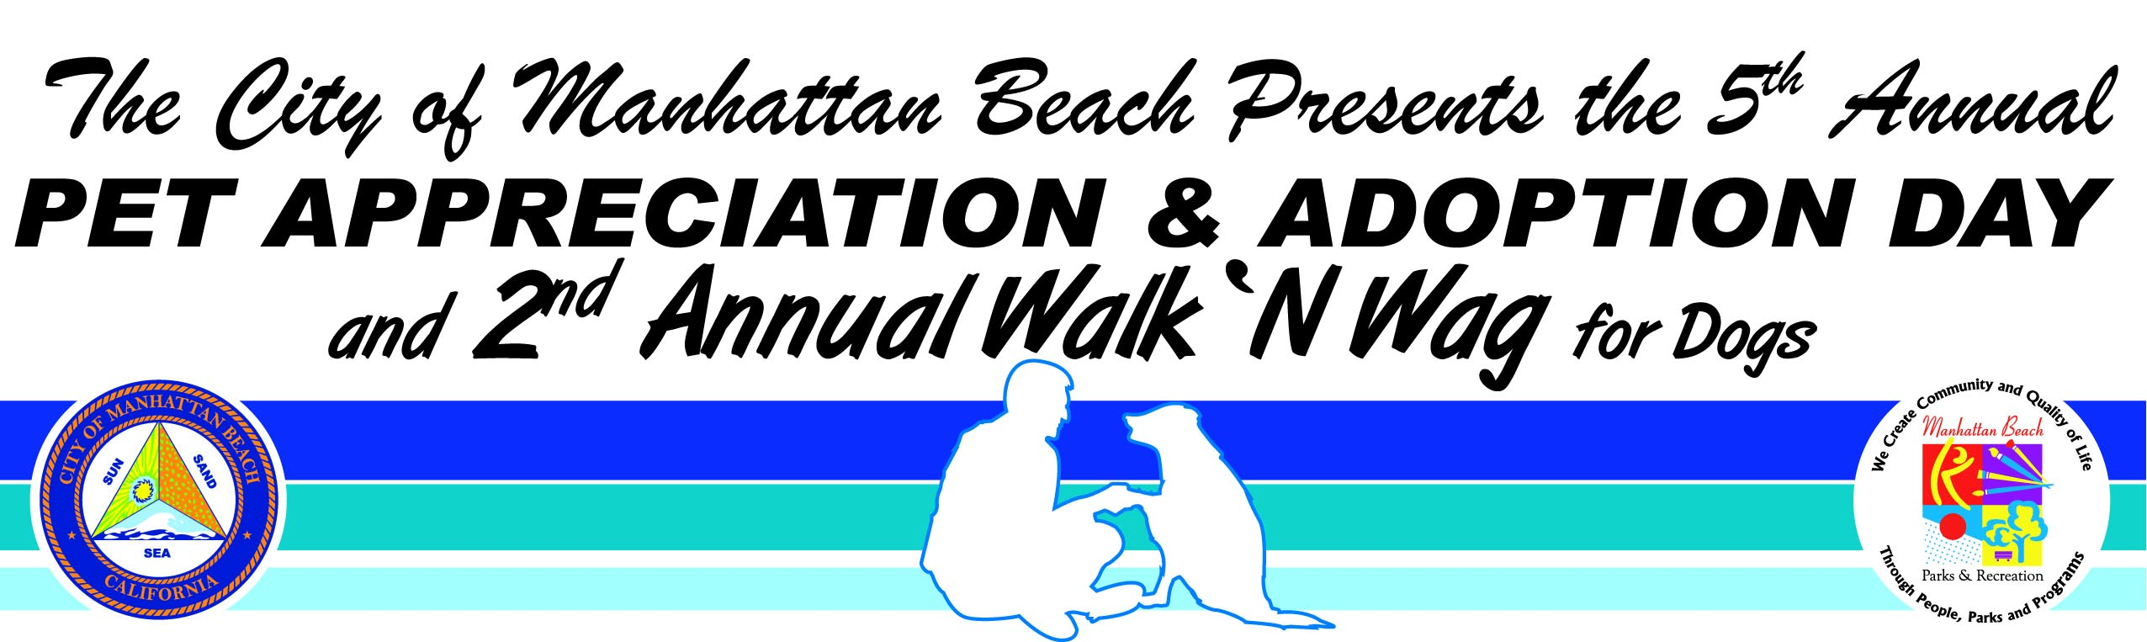

2008 BOOTH APPLICATION
Sunday, September 28, 2008 (rain date Sunday, October 12, 2008)
Live Oak Park - Dorsey Field (1901 Valley Drive)

- VENDOR: Applications received before July 18, 2008 will pay *$100.00
- VENDOR: Applications received July 19th thru August 29, 2008 will pay *$150.00
- NON PROFIT: All non profits are exempt from application fees. The first 15 rescue groups that turn in their application and show up on time for the event will receive $50.00 and be eligible to win up to $500 in donations for their group. All are required to submit proof of current 501 (C) (3) status with their application.
- Application deadline is August 29, 2008; Applications must be turned in to City Hall by 5pm
- Applicants must submit a check made out to The City of Manhattan Beach.
- Applicants must be in the pet care industry or provide a service to pets and/or owners.
- You must provide your own booth, tent, shade, table, chairs, etc.
- Applications with a check may be brought in or mailed to:

City of Manhattan Beach Parks and Recreation Department
Attention: David Ibarra, 2008 Pet Appreciation and Adoption Day Booth Application
1400 Highland Avenue
Manhattan Beach, CA, 90266

- All applications are subject to review. Non-approved applications will be returned to the address
provided and a full refund will be issued. Any applications that are incomplete or emailed will be destroyed.
If you have any questions, please contact: Mr. David Ibarra, dibarra@citymb.info or 310-802-5419

Organization/Business Name:
Applicant Name:
Address:
City: Zip code:
Phone number with area code: Fax Number with area code:
*Email:
(*Email will be our main form of communication/Email Mr. David Ibarra at dibarra@citymb.info)

Type of Booth: (Check all that apply)
Pet Trainer Pet Food Pet Adoption Pet Retail/All Pet Products
Pet Grooming Pet Care/Daycares/Vets Food Booth Pet Advocacy
Other:
Description & Explanation of Booth:
Will you have live animals? Yes No What kind?
Will you be selling products? Yes No What type?
Will you have an activity at your booth? Yes No What kind?
Will you be participating in the Silent Auction and/or raffle? (Gifts valued at $25.00 plus only) Yes No

(Each booth space will be 10’x 10’) Please describe the amount of space you will need:
Will you need water? Yes No For what use?
Special needs (quiet, near stage, near exit, etc):
“Parks and Recreation Strengthens Community Image and Sense of Place &
Promotes Health and Wellness”
Mr. Idris Jassim Al-Oboudi, Recreation Services Manager

