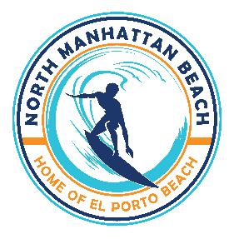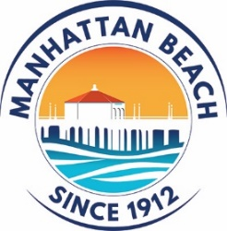**NORTH MANHATTAN BEACH BUSINESS IMPROVEMENT DISTRICT  
ADVISORY BOARD MEETING**

AGENDA

Wednesday November 13, 2024, at 6:00 PM **Manhattan Beach Chamber of Commerce**

**425 15th Street**

**Manhattan Beach, CA 90266**

1. Roll Call

1. Approval of October 9, 2024, Meeting Minutes

Action: Approve

1. Public Comment - (3 Minute Time Limit)

Speakers may provide public comments on any matter including items on the agenda. Each speaker may speak for up to 3 minutes.

1. City Councilmember/Council Liaison Steve Napolitano Updates & Comments

Action: Update and Discuss

1. NMBBID Chairman Mike Simms Updates & Comments

Action: Update and Discuss

1. MBPD Safety Update

Action: Update and Discuss

1. City Updates

Action: Update and Discuss

1. North MB BID Advisory Board Election

Action: Update and Discuss

1. Outdoor Dining Update

Action: Update and Discuss

1. Holiday Stroll 2024 Production

Action: Update and Discuss

1. Event Discussion – Art Walk and Other Ideas

Action: Discuss

1. Update on North MB Association Development

Action: Update and Discuss

1. Call for December 11, 2024, Agenda Items

Action: Review, Discuss and Vote

Adjournment:

Next Meeting: December 11, 2024, at 6:00 PM at the Chamber Offices